

Republic of the Philippines

**CEBU TECHNOLOGICAL UNIVERSITY**

DAANBANTAYAN CAMPUS

Agujo, Daanbantayan, Cebu, Philippines

Website: [http://www.ctu.edu.ph](http://www.ctu.edu.ph/) E-mail: [info-daanbantayan@ctu.edu.ph](mailto:info-daanbantayan@ctu.edu.ph)

Phone: +6332 437 8526 loc. 102/316 1905

**EXPLORING ACADEMIC**

**ADVANTAGES OF**

**INTERNET ACCESS**

**FOR STUDENTS**

ll. Group Members

LEADER:

CHENNA RABACA

GROUP MEMBERS:

GODFREY QUIJANO

KARL VINCENT PEPITO

JOHN CRISVELL PUNAY

MARK JOSHUA SABIODO

KEITH LAURENCE MONDEJAR

MATERIALS NEEDED:

LAPTOP

BONDPAPER

CELLPHONE

III. Objectives:

Exploring the academic advantages of internet access for students involves several key objectives. Firstly, understanding and evaluating the diverse array of online learning resources is crucial. This objective seeks to ensure that students have access to high-quality materials that align with the curriculum, providing them with a comprehensive and dynamic educational experience. Assessing the relevance and reliability of these resources is essential for educators to make informed decisions about integrating technology into the learning process.

Secondly, the exploration aims to assess the impact of internet access on students' academic performance. This involves studying how access to online resources contributes to improved learning outcomes, critical thinking skills, and information retention. By measuring academic success in conjunction with internet use, educators can identify patterns and insights that inform effective teaching strategies and optimize the learning environment.

Lastly, exploring the academic advantages includes an objective to analyze the development of essential skills facilitated by internet access. This involves assessing how students acquire and enhance skills such as research proficiency, digital literacy, and effective communication. Understanding the role of internet access in skill development is crucial for preparing students for the demands of a rapidly evolving, technology-driven world, ensuring they are well-equipped for future academic and professional endeavors.

Top of Form

lV. Introduction:

In the contemporary educational landscape, the integration of technology, particularly internet access, has become a defining factor in shaping the academic experiences of students. The research study titled "Exploring Academic Advantages of Internet Access for Students" embarks on an in-depth investigation into the dynamic relationship between students and the digital realm, aiming to unravel the diverse advantages that internet access can offer within the academic sphere.

The educational landscape has undergone a transformative shift with the ubiquity of internet access. As students navigate their academic journeys, the internet serves as an expansive repository of knowledge, providing access to a plethora of learning resources that transcend traditional boundaries. This study seeks to delve into the qualitative aspects of these resources, evaluating their relevance, reliability, and alignment with educational objectives. By scrutinizing the quality and diversity of online materials, the research endeavors to discern how internet access enriches the learning experience, offering students a broader and more dynamic educational palette.

Accessibility is a cornerstone of equitable education, and the study places a significant emphasis on this aspect. As technology becomes more pervasive, it is crucial to assess how readily students, irrespective of their backgrounds or geographical locations, can access online educational content. The exploration of accessibility extends beyond mere availability, delving into factors such as connectivity, device availability, and the potential socio-economic implications of the digital divide. Understanding the accessibility of internet resources is paramount for ensuring that the advantages they bring are not confined to a privileged few but are universally accessible, fostering an inclusive educational environment.

Furthermore, the study sets out to analyze the impact of internet access on academic performance. Beyond the traditional metrics of success, the research aims to uncover nuanced insights into how online resources contribute to critical thinking skills, information retention, and overall academic achievement. By measuring the tangible outcomes of internet use in conjunction with academic pursuits, the study seeks to provide educators with actionable data to inform pedagogical strategies, curriculum development, and the integration of technology to optimize learning outcomes.

As we navigate an era defined by rapid technological advancements, this research study serves as a beacon, illuminating the transformative potential of internet access in education. By unraveling the complexities and nuances of this relationship, the study aspires to offer a comprehensive understanding of how educators can harness the advantages of internet access to create a more enriched, equitable, and effective educational landscape for students.

V. Data Analysis:

|  |  |  |
| --- | --- | --- |
| RESIDUALOUTPUT |  |  |
|  |  |  |
| *Observation* | *Predicted Y* | *Residuals* |
| 1 | 20.51348232 | -2.513482321 |
| 2 | 20.51348232 | -9.513482321 |
| 3 | 16.99055713 | -1.990557129 |
| 4 | 13.46763194 | 8.532368062 |
| 5 | 24.03640751 | -12.03640751 |
| 6 | 20.51348232 | -2.513482321 |
| 7 | 16.99055713 | 3.009442871 |
| 8 | 20.51348232 | -1.513482321 |
| 9 | 13.46763194 | -1.467631938 |
| 10 | 13.46763194 | -1.467631938 |
| 11 | 20.51348232 | -6.513482321 |
| 12 | 20.51348232 | -5.513482321 |
| 13 | 20.51348232 | -7.513482321 |
| 14 | 16.99055713 | -4.990557129 |
| 15 | 24.03640751 | -11.03640751 |
| 16 | 16.99055713 | -3.990557129 |
| 17 | 20.51348232 | -4.513482321 |
| 18 | 20.51348232 | -6.513482321 |
| 19 | 16.99055713 | -2.990557129 |
| 20 | 24.03640751 | -9.036407512 |
| 21 | 16.99055713 | -0.990557129 |
| 22 | 16.99055713 | 7.009442871 |
| 23 | 24.03640751 | -12.03640751 |
| 24 | 20.51348232 | 3.486517679 |
| 25 | 24.03640751 | 122.9635925 |
| 26 | 13.46763194 | 10.53236806 |
| 27 | 24.03640751 | -11.03640751 |
| 28 | 16.99055713 | -2.990557129 |
| 29 | 13.46763194 | -0.467631938 |
| 30 | 16.99055713 | -2.990557129 |
| 31 | 20.51348232 | -7.513482321 |
| 32 | 16.99055713 | 0.009442871 |
| 33 | 16.99055713 | -1.990557129 |
| 34 | 24.03640751 | 3.963592488 |
| 35 | 24.03640751 | -10.03640751 |
| 36 | 13.46763194 | -1.467631938 |
| 37 | 16.99055713 | -0.990557129 |
| 38 | 20.51348232 | -0.513482321 |
| 39 | 16.99055713 | 7.009442871 |
| 40 | 16.99055713 | -0.990557129 |
| 41 | 16.99055713 | 7.009442871 |
| 42 | 20.51348232 | -6.513482321 |
| 43 | 20.51348232 | -8.513482321 |
| 44 | 16.99055713 | -0.990557129 |
| 45 | 24.03640751 | 0.963592488 |
| 46 | 24.03640751 | -9.036407512 |
| 47 | 24.03640751 | -9.036407512 |
| 48 | 24.03640751 | 103.9635925 |
| 49 | 24.03640751 | -9.036407512 |
| 50 | 16.99055713 | -3.990557129 |
| 51 | 20.51348232 | -9.513482321 |
| 52 | 16.99055713 | -3.990557129 |
| 53 | 20.51348232 | -7.513482321 |
| 54 | 16.99055713 | -1.990557129 |
| 55 | 13.46763194 | 1.532368062 |
| 56 | 16.99055713 | -6.990557129 |
| 57 | 24.03640751 | -9.036407512 |
| 58 | 20.51348232 | -2.513482321 |
| 59 | 24.03640751 | -0.036407512 |
| 60 | 20.51348232 | 3.486517679 |
| 61 | 13.46763194 | 34.53236806 |
| 62 | 20.51348232 | -7.513482321 |
| 63 | 24.03640751 | -8.036407512 |
| 64 | 20.51348232 | -10.51348232 |
| 65 | 20.51348232 | -0.513482321 |
| 66 | 24.03640751 | -12.03640751 |
| 67 | 16.99055713 | 1.009442871 |
| 68 | 20.51348232 | 27.48651768 |
| 69 | 24.03640751 | 25.96359249 |
| 70 | 20.51348232 | -5.513482321 |
| 71 | 20.51348232 | -7.513482321 |
| 72 | 13.46763194 | -1.467631938 |
| 73 | 24.03640751 | -10.03640751 |
| 74 | 20.51348232 | -2.513482321 |
| 75 | 20.51348232 | -6.513482321 |
| 76 | 20.51348232 | -4.513482321 |
| 77 | 16.99055713 | 1.009442871 |
| 78 | 13.46763194 | 4.532368062 |
| 79 | 16.99055713 | -0.990557129 |
| 80 | 24.03640751 | -11.03640751 |
| 81 | 16.99055713 | -0.990557129 |
| 82 | 16.99055713 | -1.990557129 |
| 83 | 16.99055713 | 0.009442871 |
| 84 | 16.99055713 | -6.990557129 |
| 85 | 20.51348232 | -8.513482321 |
| 86 | 20.51348232 | -3.513482321 |
| 87 | 24.03640751 | -9.036407512 |
| 88 | 24.03640751 | -10.03640751 |
| 89 | 16.99055713 | -1.990557129 |
| 90 | 20.51348232 | -4.513482321 |
| 91 | 20.51348232 | -2.513482321 |
| 92 | 13.46763194 | 0.532368062 |
| 93 | 16.99055713 | -0.990557129 |
| 94 | 20.51348232 | -4.513482321 |
| 95 | 16.99055713 | -0.990557129 |
| 96 | 16.99055713 | -0.990557129 |
| 97 | 13.46763194 | 5.532368062 |
| 98 | 20.51348232 | -4.513482321 |
| 99 | 13.46763194 | 2.532368062 |
| 100 | 13.46763194 | 2.532368062 |
|  |  |  |

VI. DATA:

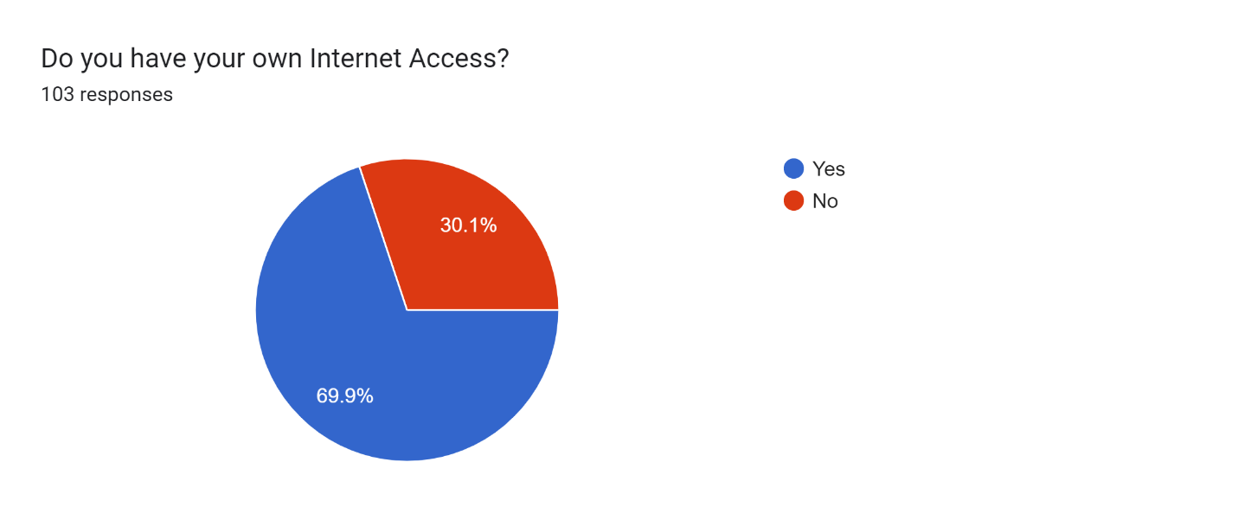

2. **On average, how many hours per week do you spend using the internet for academic activities?**

|  |  |  |
| --- | --- | --- |
| NAME : | GMAIL | NO. OF HOURS |
| Secuya, Jessah R. | [rred87654321@gmail.com](mailto:rred87654321@gmail.com) | 18 |
| Shane Steven Mondejar | [shanesteven.mondejar@ctu.edu.ph](mailto:shanesteven.mondejar@ctu.edu.ph) | 11 |
| Christan James | [christanjamessinangote@gmail.com](mailto:christanjamessinangote@gmail.com) | 15 |
| Delsie Mae Bernal | [delsiebernal@gmail.com](mailto:delsiebernal@gmail.com) | 22 |
| Ken Batomalaque | [kenachilles23@gmail.com](mailto:kenachilles23@gmail.com) | 12 |
| Stephanie Tumabini | [stephanietumabini@gmail.com](mailto:stephanietumabini@gmail.com) | 18 |
| Nina Carla Velarde | [ninacarlavelarde@gmail.com](mailto:ninacarlavelarde@gmail.com) | 20 |
| Angelo Ryan Ytang | [etherangelo@gmail.com](mailto:etherangelo@gmail.com) | 19 |
| Christian Calderon | [christiancalderon@gmail.com](mailto:christiancalderon@gmail.com) | 12 |
| Merielle Rose Melendres | [meriellerosem@gmail.com](mailto:meriellerosem@gmail.com) | 12 |
| Beth Ellen Mae Chavez | [bethellenmaechavez@gmail.com](mailto:bethellenmaechavez@gmail.com) | 14 |
| ABIEGAIL MAPULA | [abigailmapula23@gmail.com](mailto:abigailmapula23@gmail.com) | 15 |
| Mark Vincent Pabillon | [markvincent.pabillon@ctu.edu.ph](mailto:markvincent.pabillon@ctu.edu.ph) | 13 |
| Kimberly Pepito | [pepitokimberly56@gmail.com](mailto:pepitokimberly56@gmail.com) | 12 |
| Kyle josh Layos | [kylelayos@gmail.com](mailto:kylelayos@gmail.com) | 13 |
| Siara Lee Conde | [siaraleeconde@gmail.com](mailto:siaraleeconde@gmail.com) | 13 |
| Ezra Kursten T. Rosell | [ezrarosell@gmail.com](mailto:ezrarosell@gmail.com) | 16 |
| Queen Xentrix Alajid | [alajidq@gmail.com](mailto:alajidq@gmail.com) | 14 |
| Deonan Leo D. Baslan | [deonanleo.baslan@ctu.edu.ph](mailto:deonanleo.baslan@ctu.edu.ph) | 14 |
| Kent Joseph Lahoy Lahoy | [kentjosephlahoylahoy8@gmail.com](mailto:kentjosephlahoylahoy8@gmail.com) | 15 |
| Janmae Joy Ortega | [janmaejoy@gmail.com](mailto:janmaejoy@gmail.com) | 16 |
| Junel Baring | [junelbaring893@gmail.com](mailto:junelbaring893@gmail.com) | 24 |
| Reeliah Joy S. Catamco | [catamcoreelayajoy@gmail.com](mailto:catamcoreelayajoy@gmail.com) | 12 |
| Cris-Al Arreglo | [crisalarreglo217@gmail.com](mailto:crisalarreglo217@gmail.com) | 24 |
| Julia Pino | [juliapino91@gmail.com](mailto:juliapino91@gmail.com) | 147 |
| John Brian Villasencio | [d48399869@gmail.com](mailto:d48399869@gmail.com) | 24 |
| Cris James Perez | [bartexyniz@gmail.com](mailto:bartexyniz@gmail.com) | 13 |
| Kimberly Conde | [kimberlyconde44@gmail.com](mailto:kimberlyconde44@gmail.com) | 14 |
| Joshein Amag | [amagjoshein@gmail.com](mailto:amagjoshein@gmail.com) | 13 |
| Eden Mae Y. Sontousidad | [edenmaeys@gmail.com](mailto:edenmaeys@gmail.com) | 14 |
| Caryl Mae Sontousidad | [denrylys@gmail.com](mailto:denrylys@gmail.com) | 13 |
| Abegail Sunit | [sunitabegail93@gmail.com](mailto:sunitabegail93@gmail.com) | 17 |
| Denn Carlisle Torrevillas | [denntorrevillae@gmail.com](mailto:denntorrevillae@gmail.com) | 15 |
| Denielle Jhudiel Encienzo | [encienzodaniellejhudiel@gmail.com](mailto:encienzodaniellejhudiel@gmail.com) | 28 |
| Jenny Yongco | [jennyongco18@gmail.com](mailto:jennyongco18@gmail.com) | 14 |
| Regine Mae Jucdong | [reginemaejucdong@gmail.com](mailto:reginemaejucdong@gmail.com) | 12 |
| Maridel Hijapon | [hijaponmaridel@gamil.com](mailto:hijaponmaridel@gamil.com) | 16 |
| Cristylen Ancajas | [acristylen@gmail.com](mailto:acristylen@gmail.com) | 20 |
| Angelica Joy Coyoca | [angelicajoycoyoca81@gmail.com](mailto:angelicajoycoyoca81@gmail.com) | 24 |
| Reil Cañete | [reilcañete@gmail.com](mailto:reilcañete@gmail.com) | 16 |
| Jose Marie Kalayaan | [JmarieK@gmail.com](mailto:JmarieK@gmail.com) | 24 |
| Reliza Mongaya | [relizamongaya29@gmail.com](mailto:relizamongaya29@gmail.com) | 14 |
| Judy Ann Diaga | [judyannpanay20@gmail.com](mailto:judyannpanay20@gmail.com) | 12 |
| Meramae Sericon | [sericonmae@gmail.com](mailto:sericonmae@gmail.com) | 16 |
| Jozienne Maramara | [jozienne.maramara@ctu.edu.ph](mailto:jozienne.maramara@ctu.edu.ph) | 25 |
| Richelle Lato | [richelle.lato@ctu.edu.ph](mailto:richelle.lato@ctu.edu.ph) | 15 |
| Jazie Canete | [jaziecanete@gmail.com](mailto:jaziecanete@gmail.com) | 15 |
| Jason Villar | [jaysonvillar53@gmail.com](mailto:jaysonvillar53@gmail.com) | 128 |
| Resty Abel Pepito | [restybayot@gmail.com](mailto:restybayot@gmail.com) | 15 |
| Hannah Marie A. De Arca | [dearcahannahmarie15@gmail.com](mailto:dearcahannahmarie15@gmail.com) | 13 |
| Crisnessa Abellano | [dangsachavez@gmail.com](mailto:dangsachavez@gmail.com) | 11 |
| Charles Daniel Sulatan | [dandanielbaran@gmail.com](mailto:dandanielbaran@gmail.com) | 13 |
| Norbert Jalipa | [ambojalipa@gmail.com](mailto:ambojalipa@gmail.com) | 13 |
| Mervin S Gastador | [gastadormervin99@gmail.com](mailto:gastadormervin99@gmail.com) | 15 |
| Mariah Nicole Orongan | [mariahnicole.orongan@ctu.edu.ph](mailto:mariahnicole.orongan@ctu.edu.ph) | 15 |
| Abiegail Mapula | [abigailmapula23@gmail.com](mailto:abigailmapula23@gmail.com) | 10 |
| Daliejean A. Escuña | [dalescuna@gmail.com](mailto:dalescuna@gmail.com) | 15 |
| Erica Joy Estrera | [ericajoyestrera3@gmail.com](mailto:ericajoyestrera3@gmail.com) | 18 |
| Mariel Fernan | [marielfernan16@gmail.com](mailto:marielfernan16@gmail.com) | 24 |
| Mark Jun Alajid | [alajidmark045@gmail.com](mailto:alajidmark045@gmail.com) | 24 |
| Remedy Santillan | [remedysantillan@gmail.com](mailto:remedysantillan@gmail.com) | 48 |
| James Ian Gomez | [gomezjamesian123@gmail.com](mailto:gomezjamesian123@gmail.com) | 13 |
| Janlou Rosaceña | [janlourosacena3@gmail.com](mailto:janlourosacena3@gmail.com) | 16 |
| Niña Mae A. Monterde | [ninamaemonterde79@gmail.com](mailto:ninamaemonterde79@gmail.com) | 10 |
| Agnes Cabanit | [agnesabejon3001@gmail.com](mailto:agnesabejon3001@gmail.com) | 20 |
| Jayhun Castro | [jayetang08@gmail.com](mailto:jayetang08@gmail.com) | 12 |
| Virch Brylle Abao | [brylleako@gmail.com](mailto:brylleako@gmail.com) | 18 |
| Angel Cabataña | [angelcabatana61@gmail.com](mailto:angelcabatana61@gmail.com) | 48 |
| John Keith Bicare | [jkbicare@gmail.com](mailto:jkbicare@gmail.com) | 50 |
| Dan Mariel Catadman | [cdanmariel@gmail.com](mailto:cdanmariel@gmail.com) | 15 |
| Kimberly Gaviola | [gaviolakimberly079@gmail.com](mailto:gaviolakimberly079@gmail.com) | 13 |
| Jean Claude Castro | [jeanclaude@gmail.com](mailto:jeanclaude@gmail.com) | 12 |
| Angelo Monterde | [Angelomonterde@gmail.com](mailto:Angelomonterde@gmail.com) | 14 |
| Nin Kylle Valiente | [ninkyle@gmail.com](mailto:ninkyle@gmail.com) | 18 |
| Angel Mae Monterde | [AngelmaeMonterde@ gmail.com](mailto:AngelmaeMonterde@%20gmail.com) | 14 |
| Cham japhet Punay | [Chamjaphetpunay@gmail.com](mailto:Chamjaphetpunay@gmail.com) | 16 |
| Aike Zachary Maurin | [aikemaurin@gmail.com](mailto:aikemaurin@gmail.com) | 18 |
| Frank Jomarie Punay | [Frankjomariepunay@gmail.com](mailto:Frankjomariepunay@gmail.com) | 18 |
| Abeguel Duay | [Abeguelduay@gmail.com](mailto:Abeguelduay@gmail.com) | 16 |
| Christian Palconit | [Christ@gmail.com](mailto:Christ@gmail.com) | 13 |
| Christine De Los Reyes | [Christinedelosreyes@gmail.com](mailto:Christinedelosreyes@gmail.com) | 16 |
| Mary Ann B. Toyoto | [Maryann@gmail.com](mailto:Maryann@gmail.com) | 15 |
| Jovany Sanchez | [JovanySanchez@gmail.com](mailto:JovanySanchez@gmail.com) | 17 |
| Kaye Marikit | [KayeM@gmail.com](mailto:KayeM@gmail.com) | 10 |
| Marvil Palisbo | [marnil@gmail.com](mailto:marnil@gmail.com) | 12 |
| Christine Carbriana | [Christinecarbs@gmail.com](mailto:Christinecarbs@gmail.com) | 17 |
| Dona Marie Maurin | [donamariemaurin26@gmail.com](mailto:donamariemaurin26@gmail.com) | 15 |
| Mary Jean Coyoca | [maryjean@gmail.com](mailto:maryjean@gmail.com) | 14 |
| Sheena Racaza | [SheenaRacza@gmail.com](mailto:SheenaRacza@gmail.com) | 15 |
| Mark Laurence Moniodo | [MarkLaurence@gmail.com](mailto:MarkLaurence@gmail.com) | 16 |
| Franz Gian Malinao | [Franzgian@gmail.com](mailto:Franzgian@gmail.com) | 18 |
| James Cloyd Monterde | [Jamesclyd@gmail.com](mailto:Jamesclyd@gmail.com) | 14 |
| John Dave Racaza | [johndva@gmail.com](mailto:johndva@gmail.com) | 16 |
| Elizabeth Alajid | [Elizabeth@gmail.com](mailto:Elizabeth@gmail.com) | 16 |
| Rodulfo Mondejar | [Rodulfo@gmail.com](mailto:Rodulfo@gmail.com) | 16 |
| Raul Rodriguez | [Raul@gmail.com](mailto:Raul@gmail.com) | 16 |
| Keith Vincent Arreglo | [KeithVincent@gmail.com](mailto:KeithVincent@gmail.com) | 19 |
| Philip Christ Arreglado | [Philip@gmail.com](mailto:Philip@gmail.com) | 16 |
| Lester John Mondejar | [Retsel@gmail.com](mailto:Retsel@gmail.com) | 16 |
| Shaira C. Paduga | [Shairacataquezpaduga0305@gmail.com](mailto:Shairacataquezpaduga0305@gmail.com) | 16 |

3.

Forms response chart. Question title: Are students with consistent internet access more likely to achieve higher grades than those without?
. Number of responses: 103 responses.

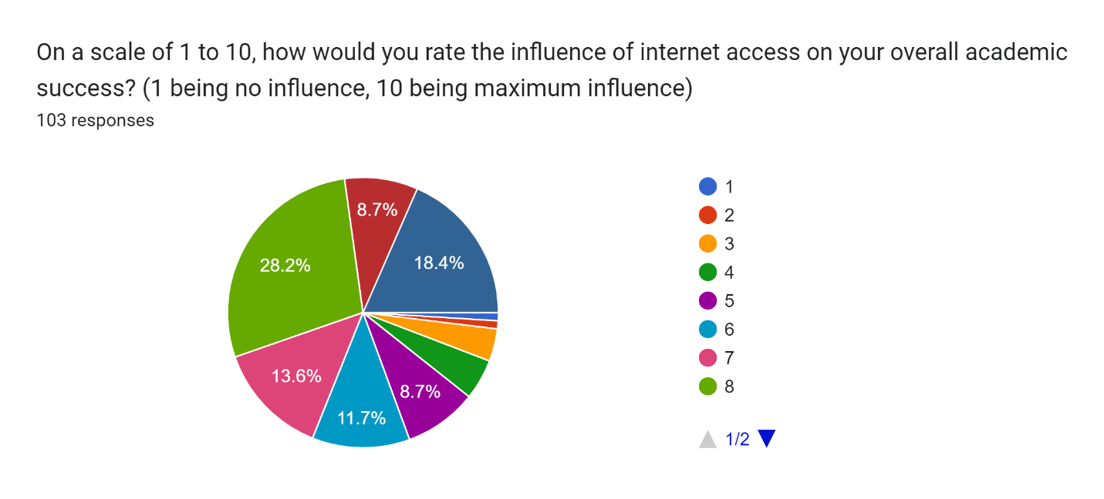

Forms response chart. Question title: To what extent do you believe internet access enhances communication and collaboration with peers and instructors for academic purposes?
. Number of responses: 103 responses.

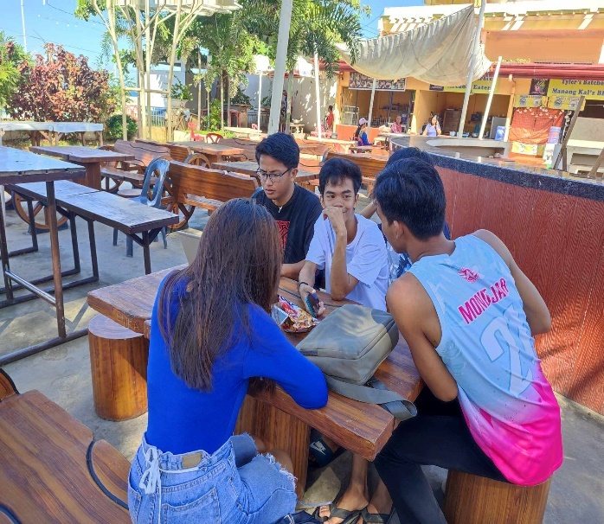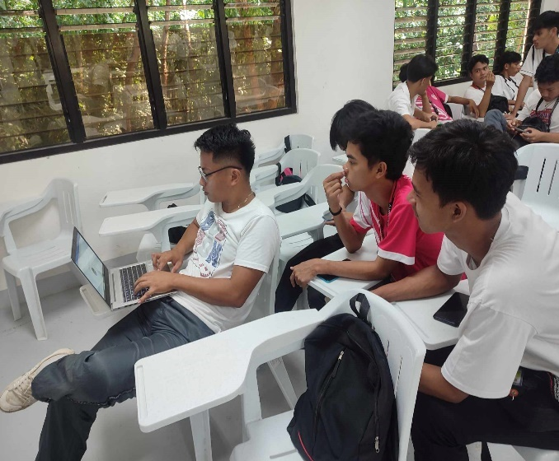VII. DOCUMENTATION:

